21st CCLC Survey Administration Resources

Central SD 13J
Please find below links to all materials and resources necessary for administration of the 21st CCLC 2025-26 school year surveys.

General Survey Administration Resources
- 21st CCLC 2025-26 School Year Survey Administration Guide
- Paper Surveys

Student Engagement Survey and Secure Submission Portal Links
- Educator Survey on Student Engagement (Grades 1-5)
- Educator Survey on Student Engagement (Grades 6-12)
- Excel Survey Secure Submission Portal

Microsoft Form Survey Links
PLEASE NOTE: The links and QR codes below are unique to your program. Each links to a version of the survey that has your grantee name pre-filled in the “Afterschool Program (Grantee) Name” field (question 1 of each survey).
Pre-filling the Afterschool Program (Grantee) Name reduces burden for respondents, 21st CCLC staff, and ODE’s evaluators, while also improving data quality.
QR Code | Survey Link
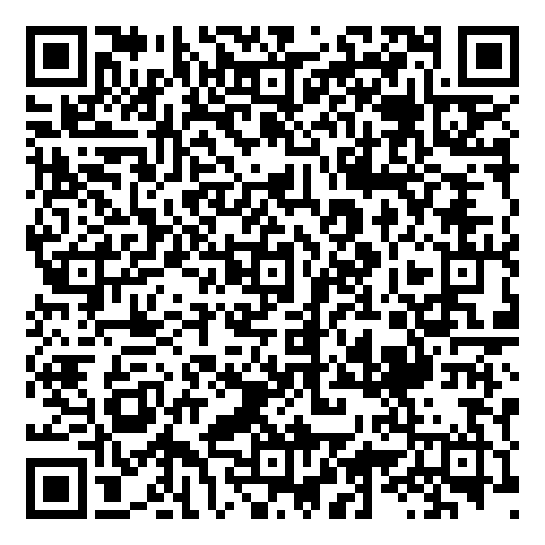 | 21st CCLC Student Survey (Grades 2-4)  Afterschool Program (Grantee) Name Pre-filled as:  Central SD
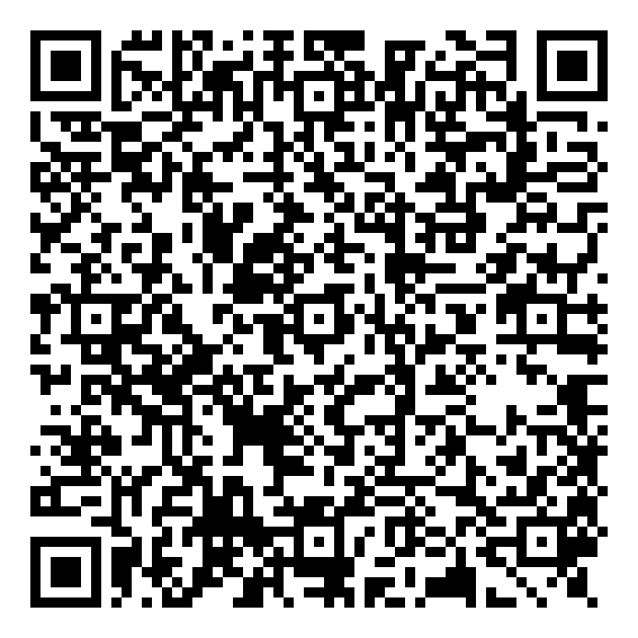 | 21st CCLC Student Survey (Grades 5-12)  Afterschool Program (Grantee) Name Pre-filled as:  Central SD
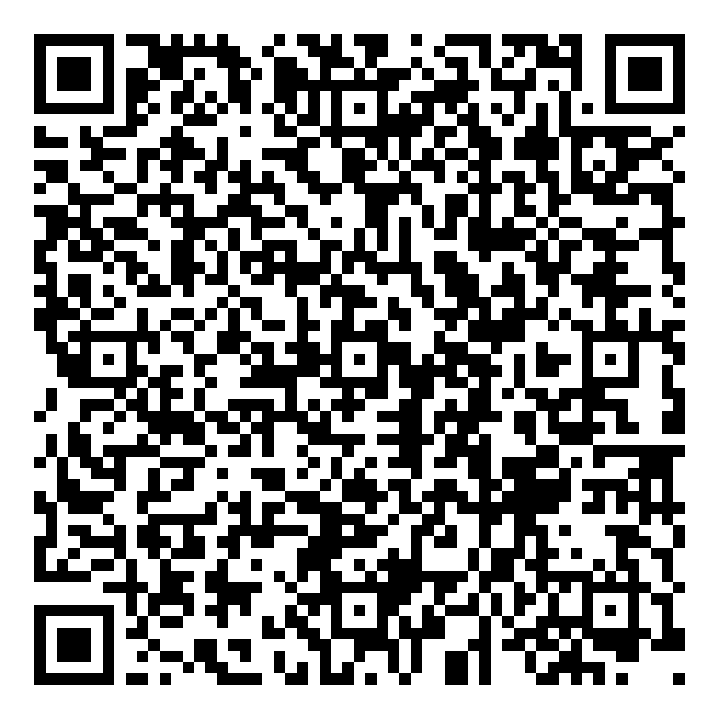 | 21st CCLC Caregiver Survey  Afterschool Program (Grantee) Name Pre-filled as:  Central SD
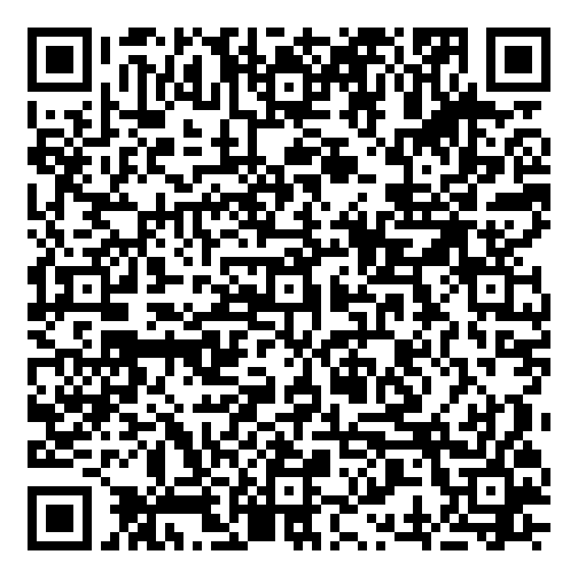 | 21st CCLC School Day Educator Feedback Survey  Afterschool Program (Grantee) Name Pre-filled as:  Central SD
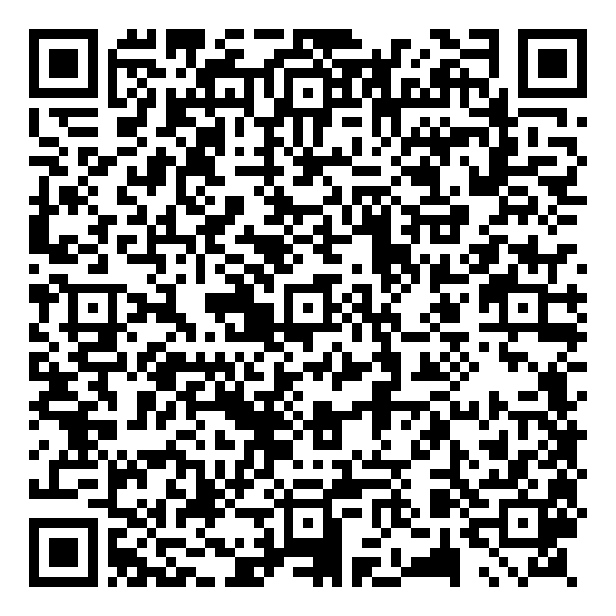 | 21st CCLC Program Staff Feedback Survey  Afterschool Program (Grantee) Name Pre-filled as:  Central SD
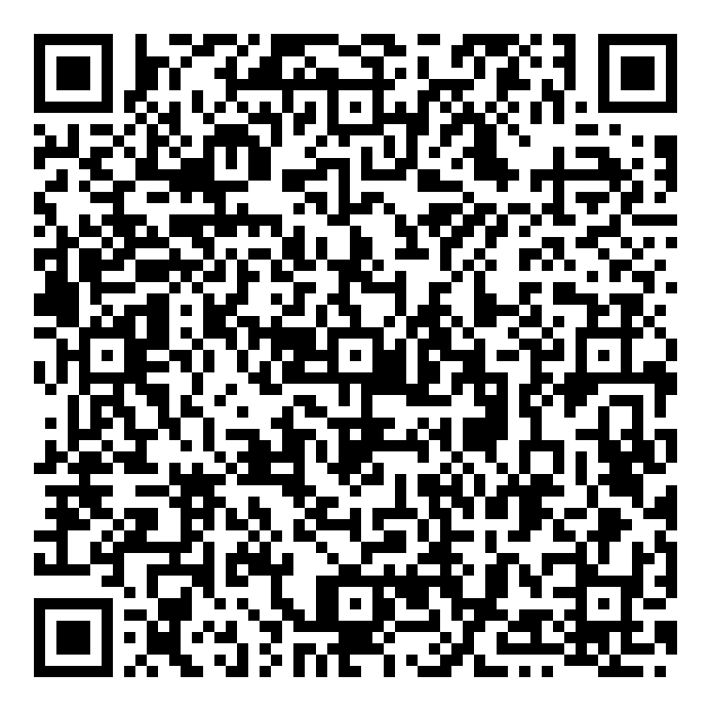 | 21st CCLC Program Admin Survey  Afterschool Program (Grantee) Name Pre-filled as:  Central SD

